Topic 10: VISCOSITY
Objectives:
At the end of this class, students should be able to
- Define and explain viscosity.
- State the effects of viscosity.
- Explain Terminal Velocity.
- Verify Viscosity Experimentally.
CONTENT
Some observations in real life are due to the property called viscosity. Some of these observations are:
- It is observed that it is easier to pour water from a container than to pour an engine oil from the same container.
- It is also observed that when a little stone is dropped in a cylinder of water, it gets to the bottom faster than when the same stone is dropped in a cylinder of engine oil.
- These observations point to the fact that engine oil is “thicker” than water.
- In science world, we say the engine oil is more viscous than that of water.
- Thus, viscosity can be considered as friction fluid.
- Viscosity can then be defined as the internal friction between layers of a fluid in motion.
- Viscous force in fluid opposes one layer from moving freely over another layer.
- Viscous force in fluid opposes the downward motion of a solid (such as stone) down the fluid.
- Mathematically, the coefficient of viscosity of a fluid (h) is given as,
h= $\frac{Force}{Area} ×(velocity gradient)^{-1}$
Velocity gradient $→change in velocity per unit lenght.$
- Its S.I unit is Ns$m^{-2}$.
- It is a vector quantity.
- The reciprocal of viscosity is fluidity.
EFFECTS OF VISCOSITY
- It is responsible for different rates of flow of fluids.
- It affects motion of bodies in fluids.
i.e. The net force on the body is zero.
- When this is attained, the acceleration of the body becomes zero and it then moves with constant velocity known as the “terminal velocity”.
EXPERIMENTAL DETERMINATION OF TERMINAL VELOCITY
Aim: To calculate the terminal velocity of a mass as it falls through a viscous liquid.
Apparatus: Viscous liquid such as glycerol, tall glass measuring cylinder, retort stand, clamp, marker pen, meter rule, steel ball bearings, strong magnet, stopwatch.
Note: Viscosity of a fluid change significantly with change in temperature.
For Liquid: the higher the temperature, the less the viscosity.
For gases: the higher the temperature, the higher the viscosity.
- Apart from temperature, viscosity is also affected by the following factors;
- Pressure
- Nature of the fluid
- Velocity gradient
TERMINAL VELOCITY
- This is the maximum velocity attainable by an object as it falls through a fluid.
- It occurs when the sum of the viscous force and the upthrust of the fluid equals the weight of the falling body.
i.e. U+$F_{v}$ = w
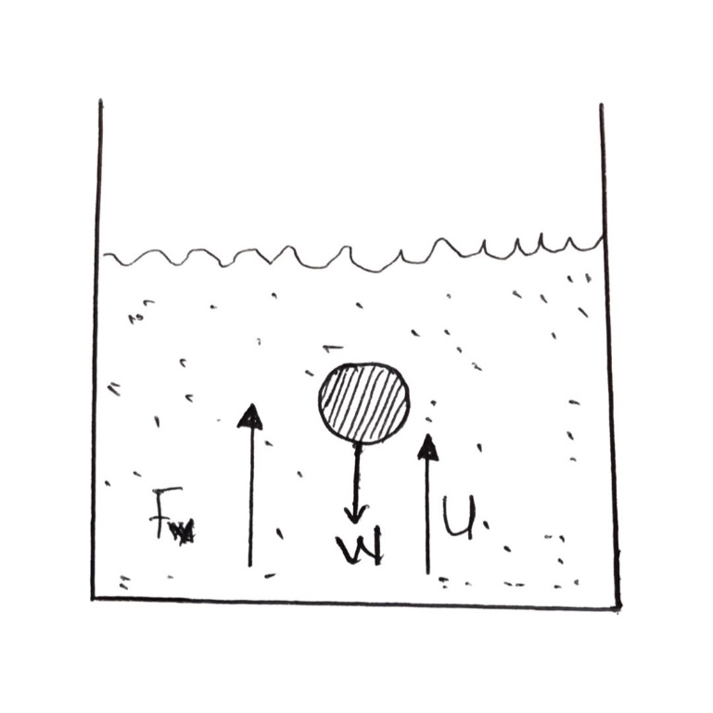
DRILL
- When the temperature of a viscous liquid is increased, its viscosity.
- Increases
- Decreases
- Remains unchanged
- Increases and then decreases
- Which of the following represents viscosity?
- Potential energy stored in fluids
- Resistance to fluid motion
- Roughness of the surface
- The pressure difference between the two fluids.
- Which of these fluids has the highest viscosity?
- Water
- Honey
- Blood
- Air
- The following are factors that can affect the viscosity of a fluid except
- Temperature
- Nature of the fluid
- Pressure
- None of the above
ANSWERS
- B
- B
- B
- D

